Project Report
1. INTRODUCTION
1.1 Project Overview
Online payment systems have become an integral part of modern digital transactions. With the rapid growth of e-commerce, mobile banking, and digital wallets, the risk of online payment fraud has also increased significantly. Fraudulent transactions cause financial losses, reduce customer trust, and negatively impact businesses.
This project, Online Payment Fraud Detection, focuses on identifying fraudulent transactions using data analysis and machine learning techniques to improve transaction security and reliability.
1.2 Purpose
The main purpose of this project is to design and develop a system that can:
- Detect fraudulent online payment transactions accurately
- Minimize financial loss for users and organizations
- Improve trust in digital payment platforms
- Assist financial institutions in real-time fraud prevention

2. IDEATION PHASE
- 2.1 Problem Statement
- Online payment platforms face increasing challenges in identifying fraudulent transactions due to high transaction volumes and evolving fraud patterns. Traditional rule-based systems are often ineffective and result in false positives.
Problem: How can we build an efficient system that accurately detects fraudulent online payment transactions while minimizing false alerts?
2.2 Empathy Map Canvas
- Users: Customers, banks, payment gateways
- Think & Feel: Concerned about security and data privacy
- See: Increasing online fraud cases and scams
- Hear: Reports of financial loss due to fraud
- Pain Points: Unauthorized transactions, delayed detection
- Gains: Secure, fast, and reliable online payments
2.3 Brainstorming
- Use machine learning models for pattern recognition
- Analyze transaction behavior
- Detect anomalies in transaction amount, frequency, and location
- Apply real-time fraud detection mechanisms
3. REQUIREMENT ANALYSIS
3.1 Customer Journey Map
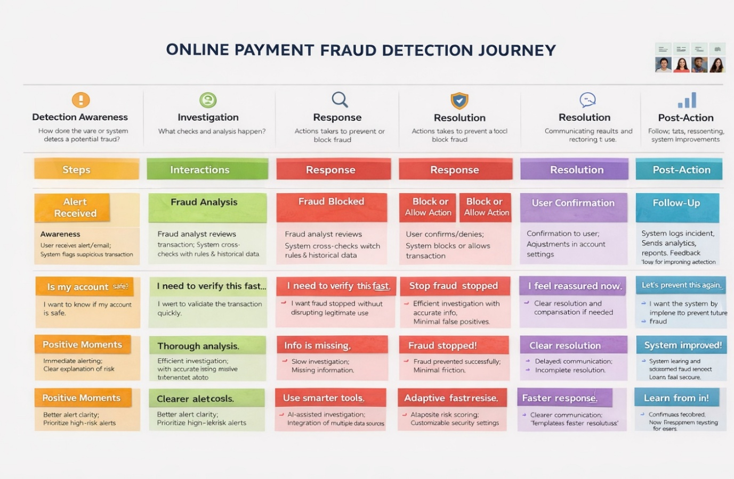

3.2 Solution Requirement
Functional Requirements
- Upload and preprocess transaction data
- Train fraud detection models
- Predict whether a transaction is fraudulent
- Display results and alerts
Non-Functional Requirements
- High accuracy and low latency
- Scalability for large datasets
- Data security and privacy
3.3 Data Flow Diagram

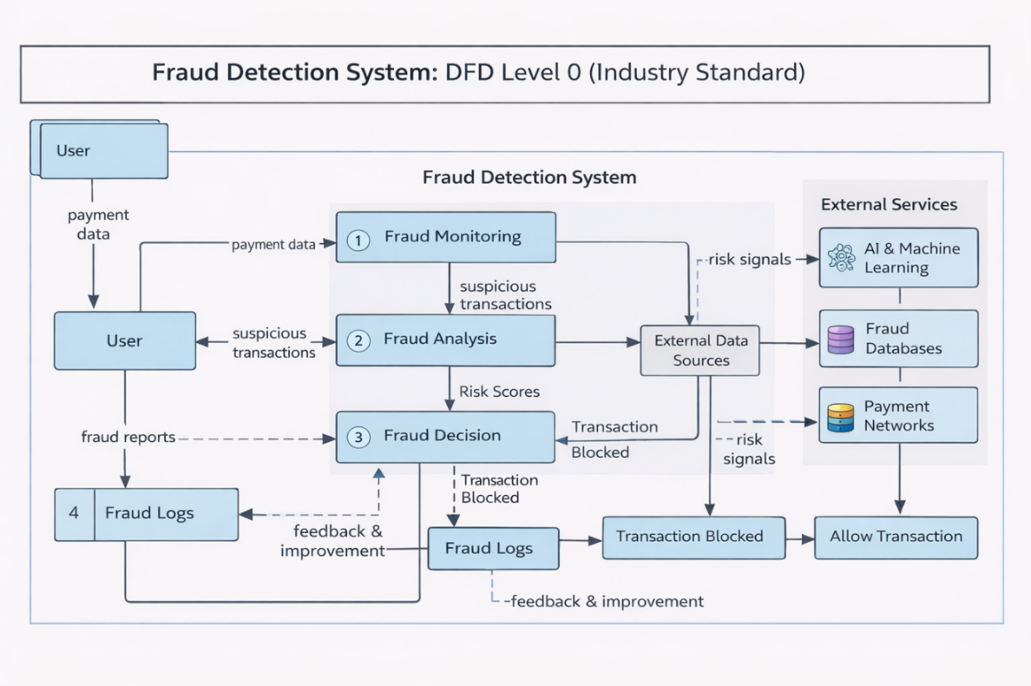

3.4 Technology Stack
- Programming Language: Python
- Libraries: NumPy, Pandas, Scikit-Learn, Matplotlib
- Tools: Jupyter Notebook / Google Colab
- Database (optional): MySQL / CSV dataset
- Version Control: GitHub

4. PROJECT DESIGN
- 4.1 Problem–Solution Fit
- The use of machine learning enables the system to learn transaction patterns and detect fraud more accurately than traditional rule-based systems.
- 4.2 Proposed Solution
- The proposed system uses supervised machine learning algorithms to classify transactions as legitimate or fraudulent based on historical transaction data.
4.3 Solution Architecture
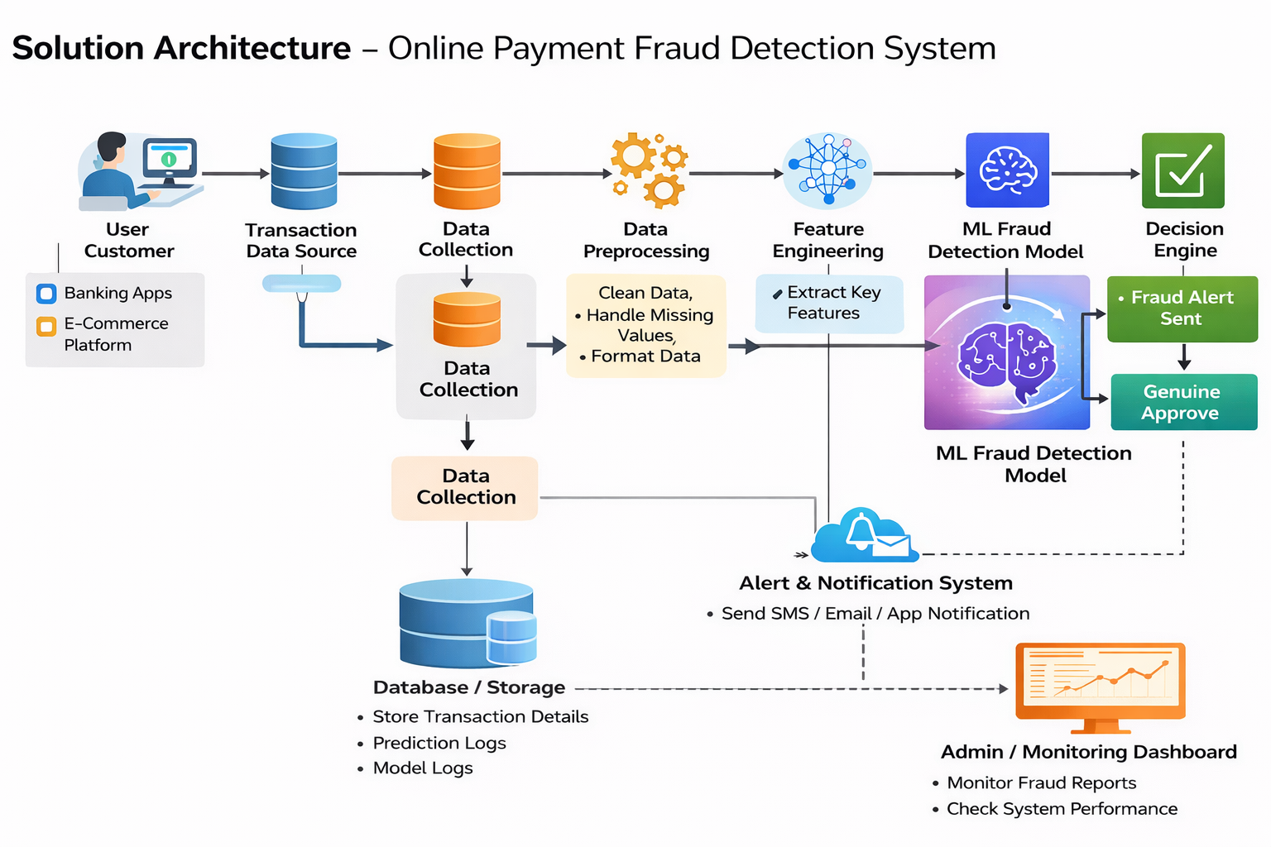
5. PROJECT PLANNING & SCHEDULING
5.1 Project Planning
- Week 1: Requirement analysis & dataset collection
- Week 2: Data preprocessing & exploration
- Week 3: Model development & training
- Week 4: Testing, evaluation & documentation
6. FUNCTIONAL AND PERFORMANCE TESTING
6.1 Performance Testing
- Accuracy
- Precision
- Recall
- F1-Score
The system is tested using a confusion matrix and evaluation metrics to ensure reliable fraud detection.

7. RESULTS
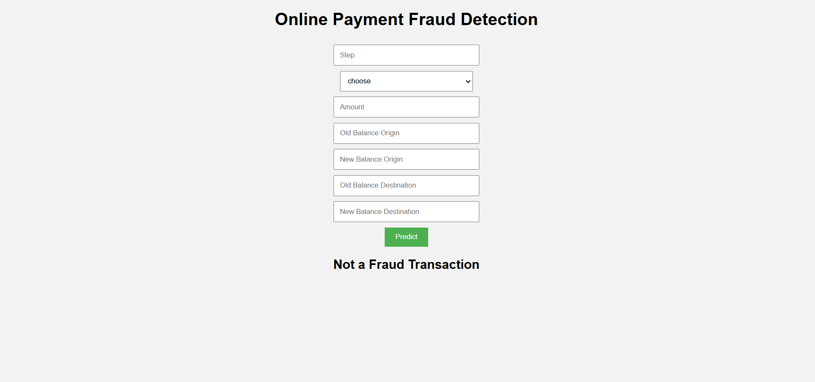
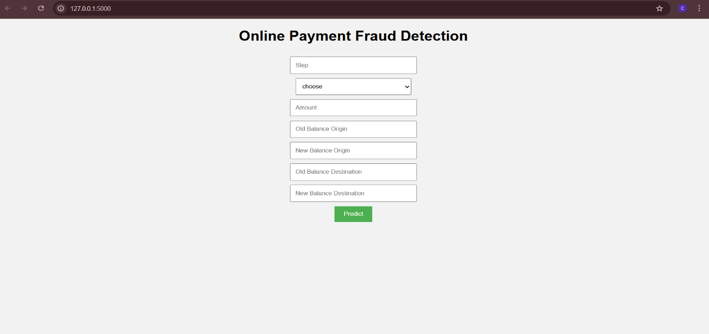
- 7.1 Output Screenshots
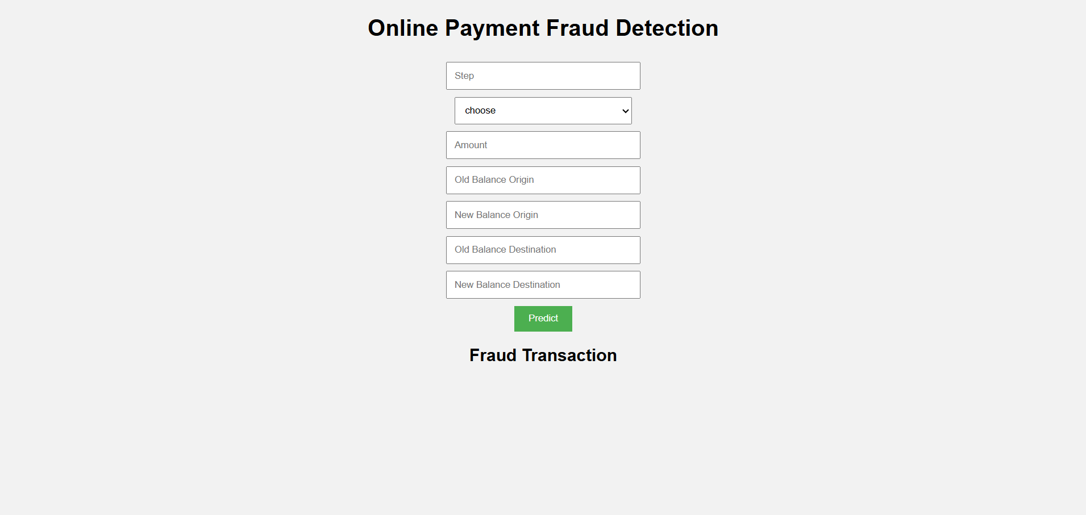

8. ADVANTAGES & DISADVANTAGES

Advantages
- High fraud detection accuracy
- Reduces financial losses
- Improves customer trust
- Automated and scalable

Disadvantages
- Requires large datasets
- Possibility of false positives
- Needs regular model updates

9. CONCLUSION

The Online Payment Fraud Detection system successfully identifies fraudulent transactions using machine learning techniques. It improves transaction security and minimizes financial risks. The project demonstrates how data-driven approaches can enhance digital payment safety.

10. FUTURE SCOPE
- Integration with real-time payment gateways
- Use of deep learning models
- Blockchain-based fraud prevention
- Adaptive learning for evolving fraud patterns

11. APPENDIX

Dataset Link
- https://www.kaggle.com/datasets/mlg-ulb/creditcardfraud

GitHub & Project Demo Link
- GitHub Repository: (Add your GitHub link here)
- Project Demo: (Add demo video or live link here)

